**Workbook #1:**

**Getting Started with Karuta**

**Introduction**

This workbook provides a basic example to help you build your first portfolio workflow using Karuta. Subsequent workbooks will show you how to create more advanced portfolios.

To follow this workbook you will need a designer account in a Karuta installation, either your own installation or the public one at <http://www.eportfolium.com/karuta>. You can create your designer account from the login page.

This workbook will guide you through the steps of creating a portfolio model and other components for a general education portfolio. After creating and testing the model, you will instantiate (i.e. copy) it to provide portfolios for each intended user.

In this tutorial you will learn how to create the following:

* A basic portfolio model with a student profile page;
* A rubric portfolio with self-evaluation and teacher evaluation rubrics;
* A reusable components portfolio with a section of portfolio that can be copy-pasted into portfolios as users need it;
* And finally two learning outcome pages to complete the portfolio model.

Karuta functions as set of interlocking portfolios. The portfolio model is the one to be instantiated (copied) for each student. In a standard scenario, the portfolio model will call upon two other portfolios: a rubric portfolio, which is used to populate choice boxes, and a reusable components portfolio, which is used to copy-paste reusable portfolio parts by end-users to add content to their portfolio as the need arises.

**Workbook 1 Screen Shots**

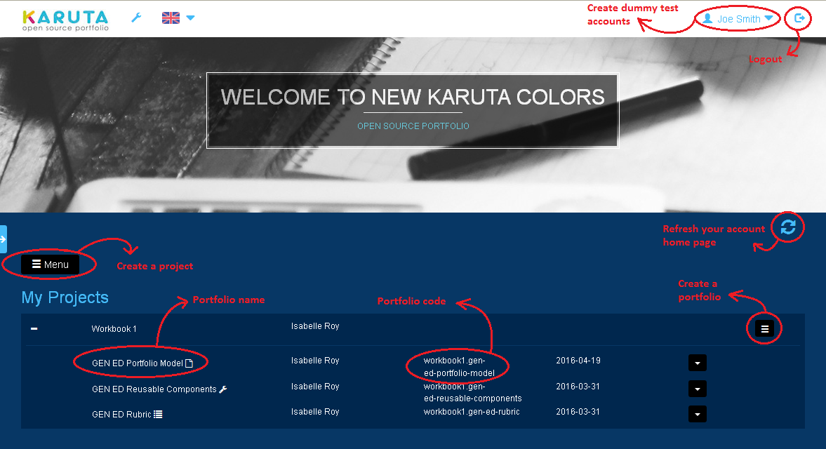**Account Home Page**

**Portfolio Root Page**

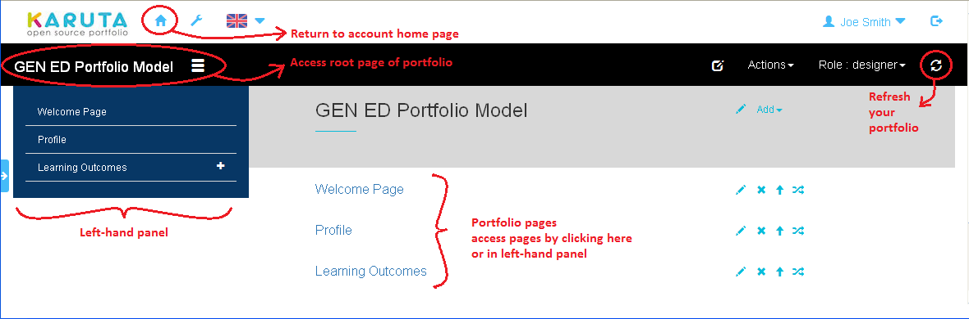

**Student Profile Page**

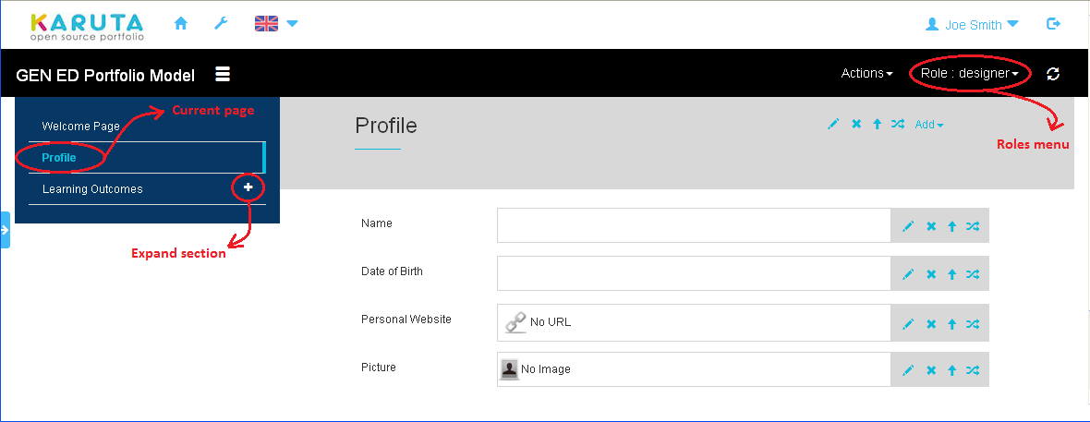

**Part I: Creating a Karuta Project**

C:\Documents and Settings\Administrator\My Documents\Dropbox\Karuta\PNG Workbook\menu button.PNG

Create a project or import previously exported portfolios.

**Portfolio and Project Codes:**

Alphanumeric characters and dashes only.

plus sign button  
Open or close a project.

stacked bars.PNG

Create portfolios in a project.

**Page Element:**A portfolio page.

add button

Add an element to a portfolio.

1. From your account home page, click the Menu button **C:\Documents and Settings\Administrator\My Documents\Dropbox\Karuta\PNG Workbook\menu button.PNG** and choose Create a Project. The project will contain all the portfolios you create using this workbook.
2. In the dialog box, enter a code and a label for the project.
   1. The code is used internally by Karuta and can only include alphanumeric characters and dashes (no spaces or any other characters including accents and other punctuation).
   2. Project codes must be unique on the Karuta server. For this reason we recommend you append your name or employee ID to your project code.
   3. The label is a more user-friendly name for users to refer to the project.
   4. For this example, enter “workbook1-*your*-*name*” for the code and “Workbook 1 - *Your Name*” for the label.

3. Open the project by clicking the plus sign to the left of the project name **C:\Documents and Settings\Administrator\My Documents\Dropbox\Karuta\PNG Workbook\plus sign button.PNG**.

**Part II: Creating a Basic Portfolio Model with a Profile Page**

1. Click the stacked bars button for your project **stacked bars.PNG** and choose Create a Portfolio Model.
2. In the dialog box, enter a code and a label for the portfolio.
3. Portfolio codes and labels follow the same rules as those for a project.
4. Portfolio codes must be unique within a given project.
5. For this example, enter “gen-ed-portfolio-model” for the code and “GEN ED Portfolio Model” for the label. Karuta will automatically prefix your code with the name of your project.

3.   Open the portfolio model you created by clicking on its label on your account homepage.

1. When you open a portfolio model, you land on the user’s welcome page. As a designer, you need to start adding pages from the root page. To access the root page, click on the portfolio name at the top left of your screen.
2. For this portfolio model, begin with a first page for the student to enter basic profile information.
3. Create the page by clicking the Add button **C:\Documents and Settings\Administrator\My Documents\Dropbox\Karuta\Workbook 1\PNG\add button.PNG** and choosing Page. Open the new Page element by clicking on its label (“New Page”).
4. The pencil button **C:\Documents and Settings\Administrator\My Documents\Dropbox\Karuta\PNG Workbook\pencil button.PNG** will allow you to rename the page. Label it “Profile”. (At this time you do not need to enter a code for elements inside a portfolio.)

C:\Documents and Settings\Administrator\My Documents\Dropbox\Karuta\PNG Workbook\pencil button.PNG

Edit an element.

**Field Element:**A short text.

**Calendar Element**A date.

**URL Element:**A hyperlink.

**Image Element:**An image file.

house.PNG

Return to your account home page.

4.  There are multiple types of data elements with which users can enter information in a portfolio. We will use four of these on the Profile page, for the name, date of birth, website and picture of the student.

a. Click the Add buttonand choose Field.

b. Click the pencil button to open the dialog box to edit this element.

c. Give the Field element the label “Name”.

d. In the same dialog box, click the Metadata tab and assign the Edit Resource role to students by typing “student” in the corresponding box. This means students will have the pencil button to edit this element.

e. You can choose whatever names you want for the roles of the various users of your project and Karuta will create them dynamically. In this tutorial we use “student” and “teacher” because they are most common.

f. Close the dialog box.

5. Click the Add button successively to add a Calendar element for the date of birth, a URL for the student’s personal website, and an Image for the student’s picture. In each case, use the pencil button to label the element and assign the Edit Resource role to “student”.

6. The Profile page is now complete. Click the house icon house.PNG at the top left of the pageto return to your Karuta account home page.

**Part III: Creating a Rubrics Portfolio**

1. Click the stacked bars button of your project and choose CreateRubrics. Give the new portfolio the code “gen-ed-rubric” and label it “GEN ED Rubric”. Open the GEN ED Rubric portfolio by clicking on its label.

2. Click the Add button and choose Page to create a new page. Open the page by clicking on its label (“New Page“).

a. Use the pencil button to rename the new page “Miscellaneous Rubrics”.

b. Click the Add button and choose Subsection to add a subsection to this page. Use the pencil button to rename the subsection “Self Evaluation” (Label field).

**Subsection Element:**Subsection on a portfolio page.

**Item Element:**One element of a choice box.

3. Click the Add button of the Self Evaluation subsection and add an Item element to the subsection.

a. Click the pencil button to edit the Item element.

b. Click the Metadata tab and assign a Semantic Tag. All Item elements that will appear in the same choice box must share the same semantic tag. Like the portfolio code, only alphanumeric characters and dashes can be used for the semantic tag. In this case, assign the semantic tag “self-evaluation”.

d. In the same dialog, click the Resource tab. For the Item Code, enter “@SMILEY-HAPPY” (using all caps).

e. Add two more Item elements to the Self Evaluation subsection, with the same semantic tag and Item Codes respectively “@SMILEY-NEUTRAL” and “@SMILEY-SAD”.

4. Add another Subsection element to the Miscellaneous Rubrics page and rename it “Teacher Evaluation” (Label field).

a. Add three more Item elements to the Teacher Evaluation subsection.

b. These three Items must share the same semantic tag. In this case, we will assign the semantic tag “teacher-evaluation”.

c. For the first Item, assign the Item Code “@BDG1” (all caps) and Item Label “Has not reached the objective”.

d. For the second Item, assign the Item Code “@BDG4” (all caps) and Item Label “Has reached the objective”.

e. For the third Item, assign Item Code “@BDG5” (all caps) and Item Label “Has exceeded the objective”.

5. The rubric is now complete. Return to your Karuta account homepage via the house icon.

**Part IV: Creating a Reusable Components Portfolio**

1. Click the stacked bars button of your project and choose CreateComponents.Give the new portfolio the code “gen-ed-reusable-components” and label it “GEN ED Reusable Components”. Open the Components portfolio by clicking on its label.

2. We want to give students a way to submit as many artifacts if they need to. For this we will create a section of portfolio the students can paste in their portfolio if and when they need it.

**Document Element:**  
A file of any type, not displayed but downloadable.

C:\Documents and Settings\Administrator\My Documents\Dropbox\Karuta\Workbook 1 (Duplicate)\PNG\duplicate button.PNG

Duplicate a section of portfolio.

a. Add a subsection to the portfolio, and rename it “Additional Document to Be Added by Students”.

b. Add a Document element to the new subsection and label it “Evidence”. Under the Metadata tab assign the unique semantic tag “student-document” and assign “student” to the Edit Resource, Deleteand Move roles.

c. The Edit Resource role specifies who can add a document – in this case the user with the Student role. The Delete role will allow the student to remove any Document elements added by mistake. The Move role will allow the student to modify the order in which the Document elements are presented.

**Part V: Creating a First Learning Outcome Page in the GEN ED Portfolio Model**

1. Open the GEN ED portfolio model by clicking on its label.Go to the root page of the portfolio model and add a new page.

a. Rename the page “Written Communication” and assign it the semantic tag “learning-outcome-page” (you will need this in Workbook 2 when you want to query all learning outcome pages to create a dashboard).

b. Assign the Duplicate role to “designer”. This will allow you to duplicate this page for other learning outcomes. Verify that the Duplicate button C:\Documents and Settings\Administrator\My Documents\Dropbox\Karuta\Workbook 1 (Duplicate)\PNG\duplicate button.PNG appears among the other buttons for this page.

2. Open the Written Communication Page and add a Subsection element as a first subsection. Rename it “Evidence Submission”.

a. In the Metadata tab assign the Submit role to “student”. This allows students to submit their evidence when they are ready. After submission, students can no longer modify their submissions. This represents the virtual equivalent of handing in a physical copy to the teacher.

3. Click the Add button of the Evidence Submission subsection and add a Document element. Use the element’s pencil button to label it “Evidence” and assign the Edit Resource role to “student”.

4. Add a TextField element to the Evidence Submission subsection. Label it “Documentation and Reflection” and assign the Edit Resource role to “student”.

**GetResource Element:**A choice box.

**menu button.PNG**

Custom menu (may be created for use by designer or end-user).

5. Add a Get_Resource element to the Evidence Submission subsection. This will create a choice box.

a. Label the new element “Self Evaluation” and assign the Edit Resource role to “student”.

b. To specify which choices will populate the choice box, scroll down to find the Search field at the bottom of the Metadata tab and enter the following:

i. the rubric portfolio code, followed by a dot;

ii. the semantic tag of the Item elements that will populate the choice box, followed by a dot;

iii. the word “label”.

c. In this case the result is “gen-ed-rubric.self-evaluation.label”.

d. Close.

e. Click the pencil button for Self-Evaluation again and click the downward arrow to make sure the choice box appears.

6. Add a Send Email element to the Evidence Submission subsection.

a. Click the pencil button and fill in the first name, last name, and email address of the intended recipient. (You can use this information to create a test user account later in the process.)

b. Assign “student” to the Edit Resource role.

7. The last step to complete the Evidence Submission subsection is to create a custom Menu allowing the student to add extra documents as needed. Use the pencil button for the Evidence Submission subsection to open the editing dialog box for this element.

a. Find the Menu field at the bottom of the Metadata tab and enter the following:

i. The reusable components portfolio code, followed by a comma;

ii. The semantic tag of the reusable element, followed by a comma;

iii. What you want the menu to say to the user, appended by the language tag “@en”, followed by a comma;

iv. The role of the user who will have this custom menu.

* 1. In this case, the result is as follows:

“gen-ed-reusable-components,student-document,Additional Document@en,student”.

c. Close.

d. Click the new Menu button menu button.PNG to review the newly available option.

8. Add a second subsection to the Learning Outcome page and label it “Teacher Evaluation”.

a. Add a Get_Resource element to this subsection, label it “Evaluation”, assign the Edit Resource role to “teacher”, and edit the Search field at the bottom of the Metadata tab as follows: “gen-ed-rubric.teacher-evaluation.label”.

b. Add a TextField element, label it “Comments”, and assign the Edit Resource role to “teacher”.

9. The first Learning Outcome page is now complete. Return to the portfolio root page.

**Part VI: Creating a Second Learning Outcome Page from the First One**

1. Open the GEN ED Portfolio Model’s root page. Click on the Duplicate button for the Written Communication page. A duplicate of this page will be created. Use the pencil button for the new page to rename it “Teamwork and Collaboration”.

2. In this manner you could add as many Learning Outcome pages as needed.

3. The portfolio model is now complete.

**Part VII: Checking the Portfolio Model**

1. Refresh your portfolio using the refresh button to update the left hand panel and the roles menu. (This is when Karuta creates your roles dynamically.) You should always do this after pasting parts and/or renaming Sections and Pages.

a. Click the Role dropdown menuat the top right and choose student. The screen will display what a student would see.

b. Open the profile page and make sure the student has a pencil button for every element.

c. Click Learning Outcomes in the left panel and open each of the two pages. Make sure the student has the Menu and Submit buttons in the Evidence Submission subsection and the pencil button for all elements inside this subsection.

1. Click the Role dropdown menu again and choose teacher. The screen will display what a teacher would see.

a. On each of the two learning outcomes pages, make sure you see the pink Not Submitted label and pencil buttons for the Evaluation and Comments elements.

**Part VIII: Instantiation and Sharing**

user button

Change your password or create test accounts.

downward arrow button

Take an action on a portfolio.

1. For this last step, you need to create two dummy user accounts for testing. You can create test user accounts from your account homepage with the user menu button C:\Documents and Settings\Administrator\My Documents\Dropbox\Karuta\PNG Workbook\user button.PNG at the top right of your screen.

2. Creating copies of the model for each portfolio user is called instantiation and sharing. When you do this for a large group of students, you will use a Karuta batch script. But first, to test your model, you should complete the testing cycle by creating one user portfolio manually.

a. From your account home page, click on the downward arrow button **C:\Documents and Settings\Administrator\My Documents\Dropbox\Karuta\PNG Workbook\downward arrow button.PNG** next to GEN ED Portfolio Model and choose Instantiate.

b. The new instance will have the word “-instance” appended to the portfolio code.

c. Click the downward arrow button for the new instance and choose Rename.

d. Revise the code for the new portfolio to “gen-ed-portfolio-joe-smith” and the label to “GEN ED Portfolio - Joe Smith”.

3. After instantiation, the portfolio must be shared with its different users.

a. Using the same downward arrow button, choose Share with Users. Select the student role and choose one of your dummy accounts. Then click Share. The person’s name will appear in the top shared section.

b. Select the teacher role and select your other dummy account. Click Share. The person’s name will appear in the top shared section.

4. Now you can log into these two user accounts and make sure that the portfolio is functioning correctly. With dummy users you should be able to test everything.